**PACKAGE PUBLISHING:**

To publish the jar package of the Project and register it into the gitlab Project package register, firslty we had to create a file name “settings.xml” inside of the Project containing the following content:

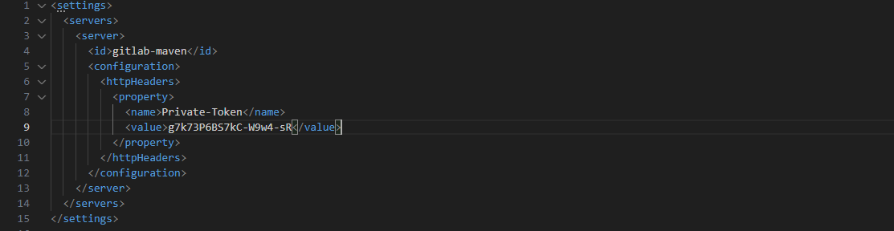

* Uses the private Access token generated by the gitlab Project
* Defines the id of the repository for the project

We had to modify the pom.xml, adding the next lines:

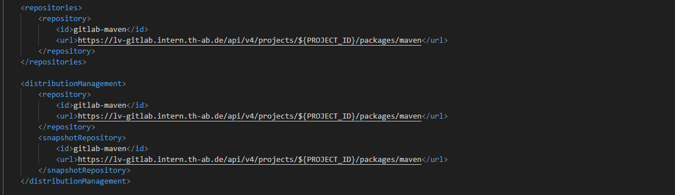

* Defines the endpoints where the package is going to be stored

And finally add to the pipeline the maven lifecycle stage needed for the publishing using the settings described in the previous parts:

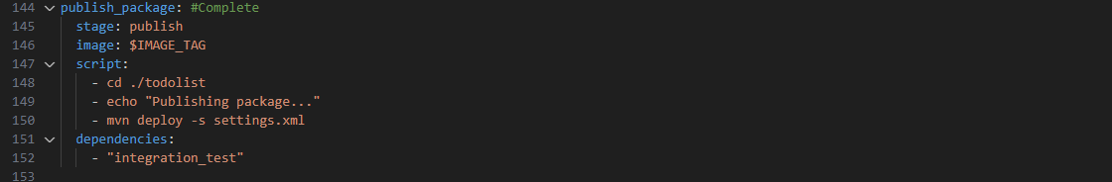

Obtaining the next succesful result:

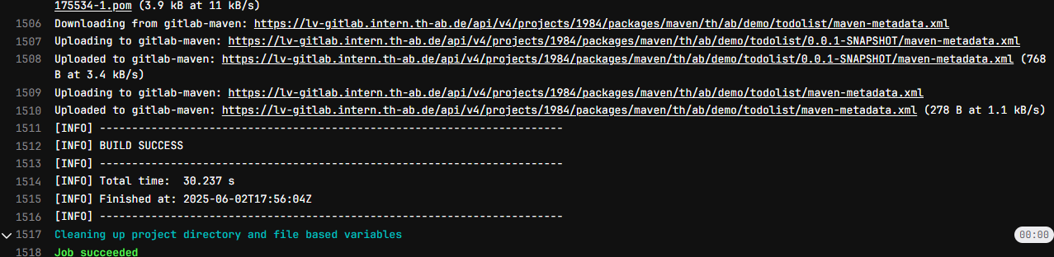

**CONTAINER PUBLISHING:**

For the purpose of scanning the container in one of the later stages of the pipeline, first we have to publish the image with the projects inside of them, creating it with a custom DockerFile with the following code:

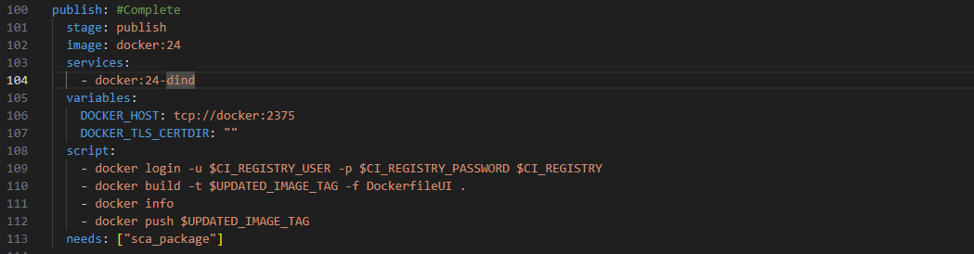

The image created that we are gonna publish is based on the following DockerFile:  
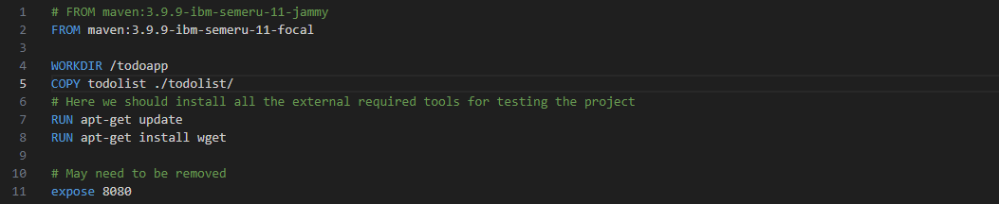

* From the version of maven that does not conflict with the Project dependencies
* Copying the Project inside of the image
* Installing wget for the pipeline to run
* Exposing the port 8080, which is used for springboot running projects